DATA ANALYTICS

ASSIGNMENT 2

MUPPIDI VAMSITHA REDDY

Vamsithareddym@gmail.com

20T91A1226

**DONUT CHART**

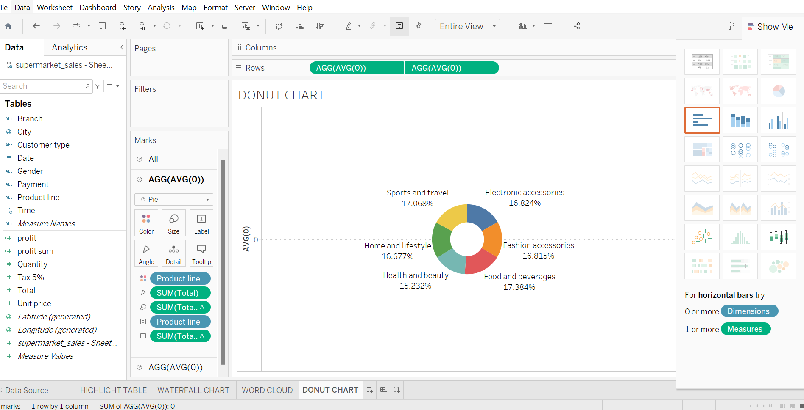

**AREA CHART**

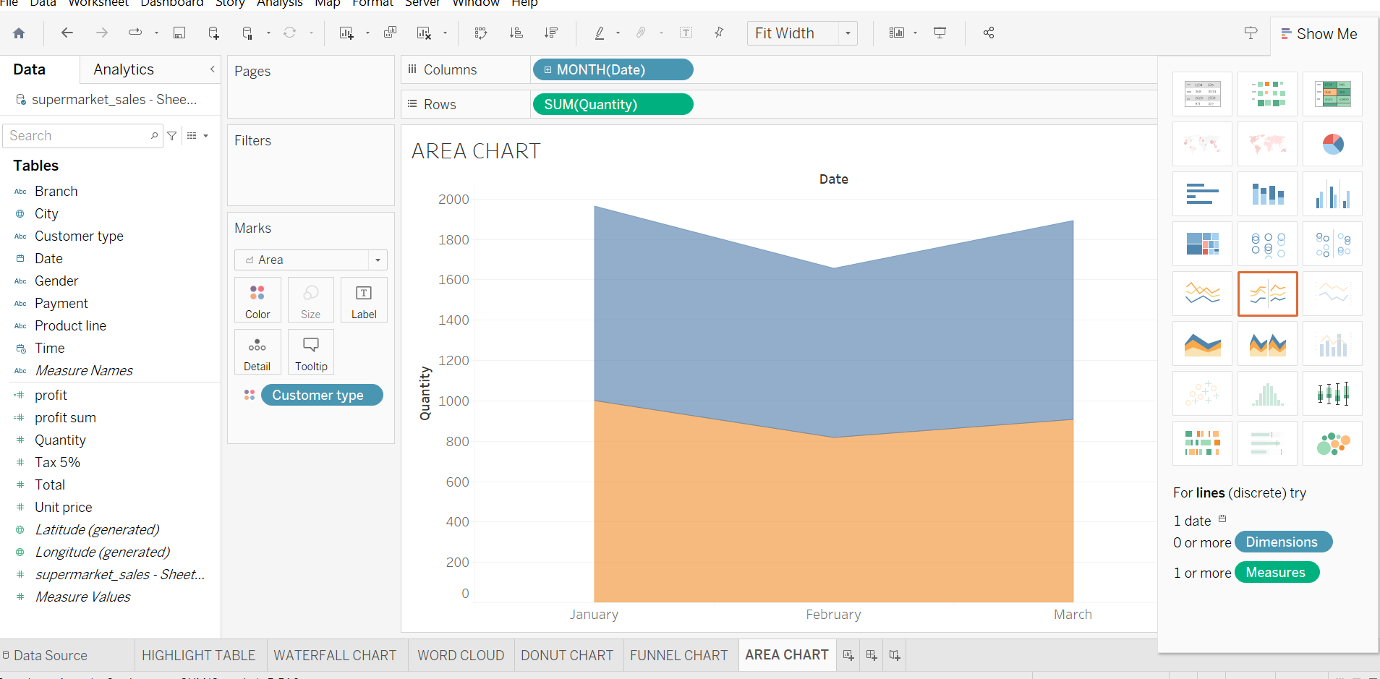

**TEXT TABLE**

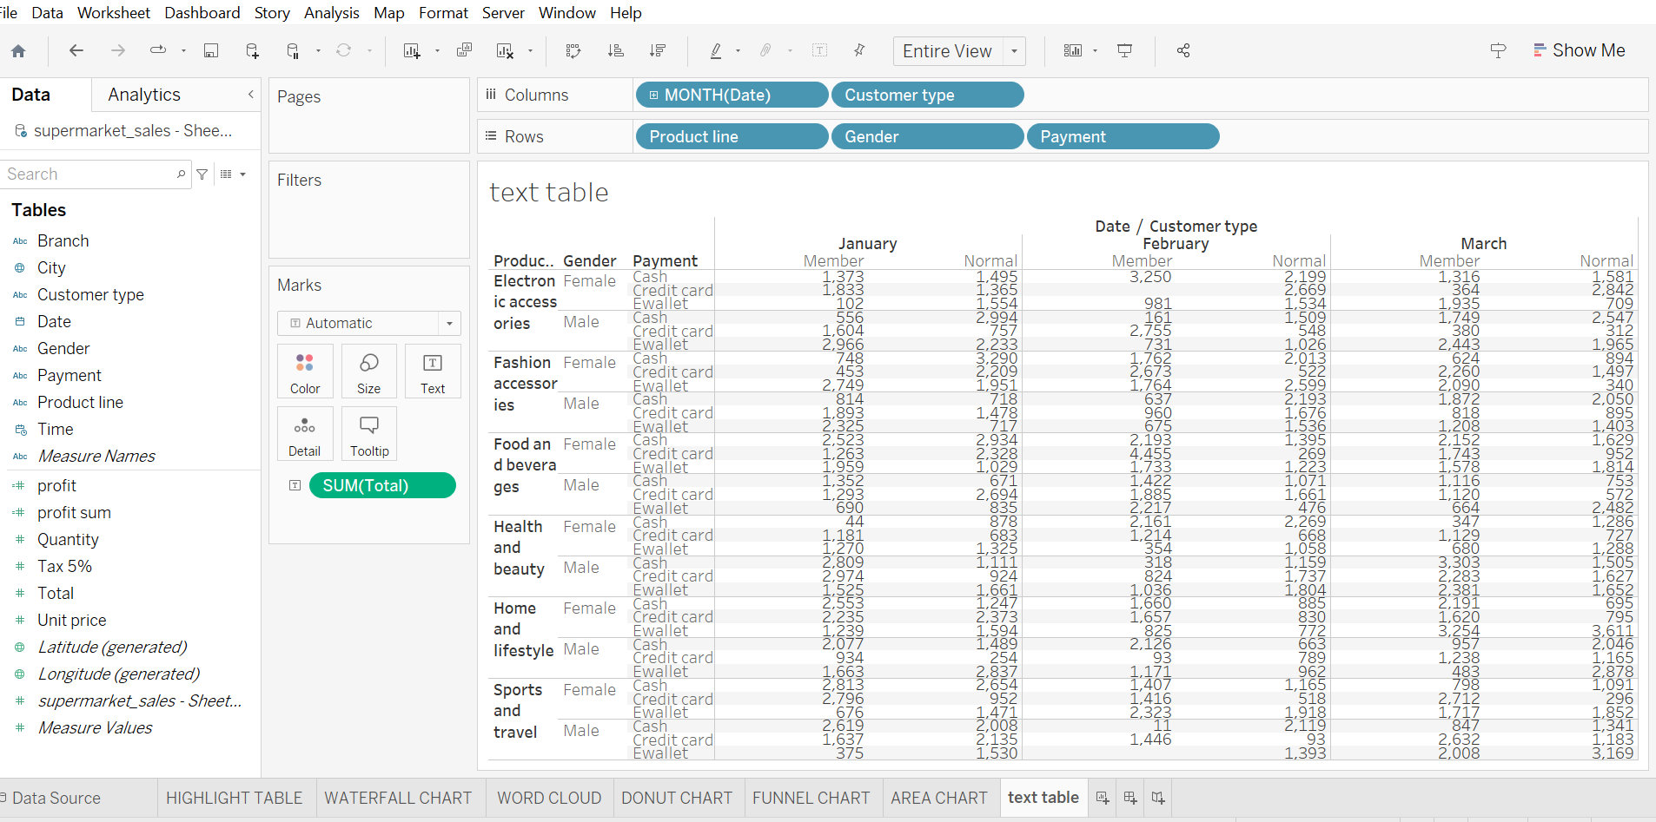

**HIGHLIGHTED TABLE**

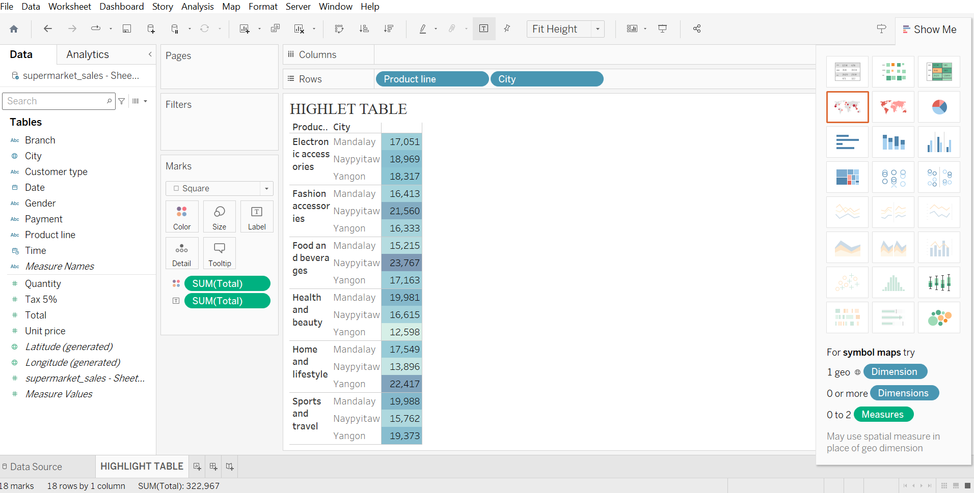

**WORD CLOUD**

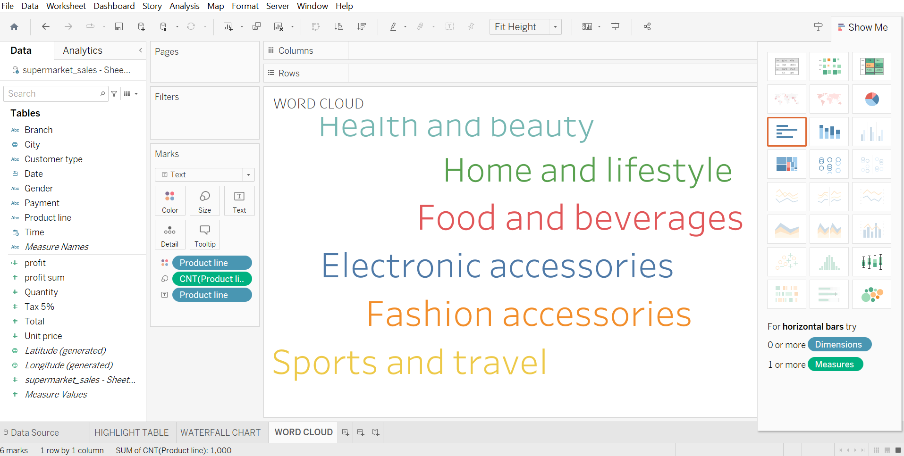

**FUNNEL CHART**

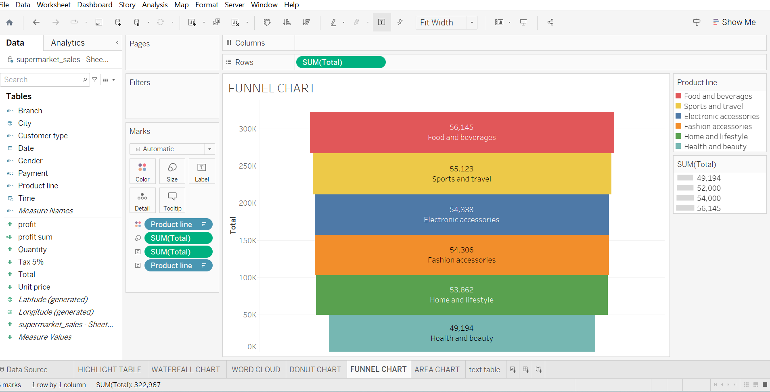

**WATER FALL**

